**Trello y Kanban**

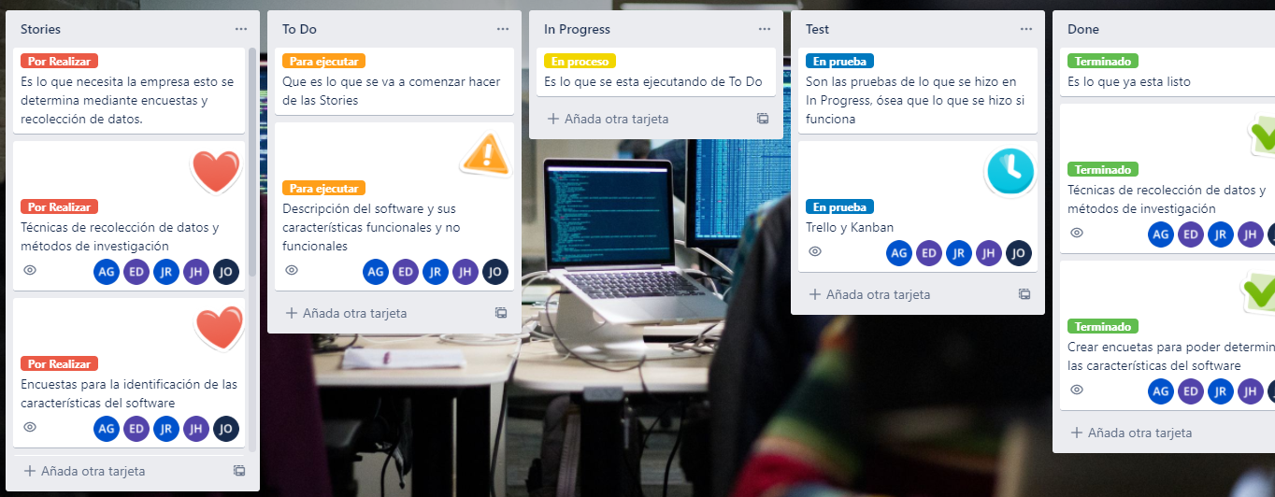**Kanban**

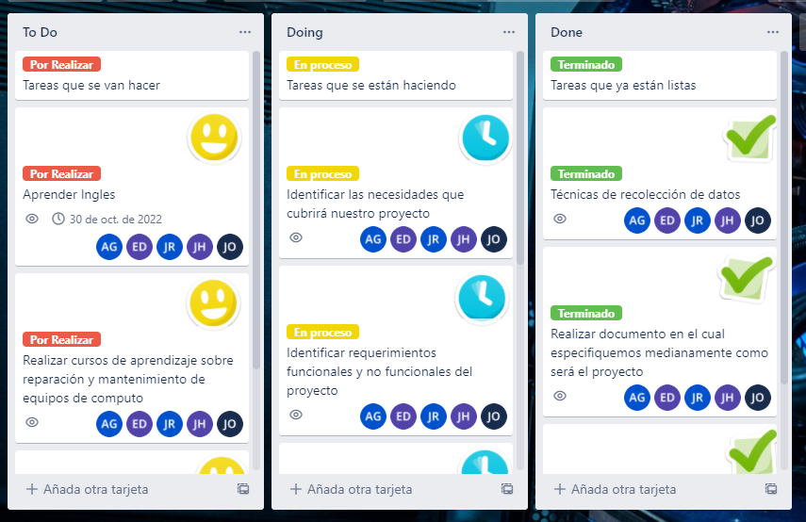**Trello**

https://trello.com/invite/b/VJUoCPWp/f82b41af8439af84a547c0464ecfcfa4/kanban